Harvest Festival at NBJS

In October we held our own harvest festival assembly. We listened to the reasons why people celebrate Harvest time, how they might celebrate it and listened to a story about a little girl’s thoughts on her local church celebration.
Year 3 then shared the work they had been doing in RE over the past half term on the concept of thanking. They explained very clearly to everyone about how Jews celebrate Sukkot, how Christians celebrate Harvest and read a selection of their Harvest prayers. They had worked very hard and had clearly understood their concept of thanking.
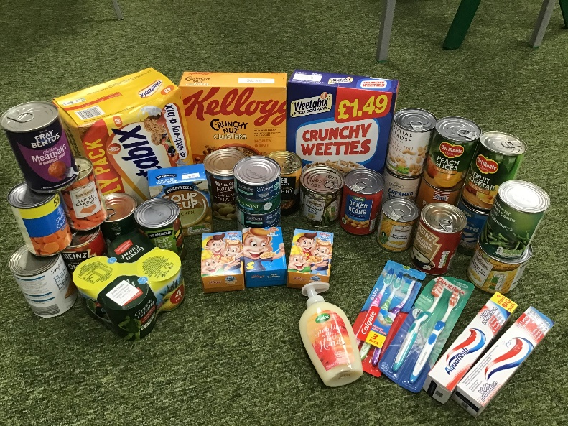
In our classes we also brought in food from home to make a collection for 2 local charities – the Southampton Mission Bank and the North Baddesley Food Bank run by True Life. We collected an amazing amount to donate to the charities, which they were very grateful for in these times of need for so many people.


